**Lab 04**

**[CLO-01, PLO-01, P3(Guided Response), Rubric (Hardware Configurations)]**

**Introduction of Workshop Practice Engineering Tools and Equipment’s and their use in Computer Engineering**

1. **Introduction to Oscilloscope**

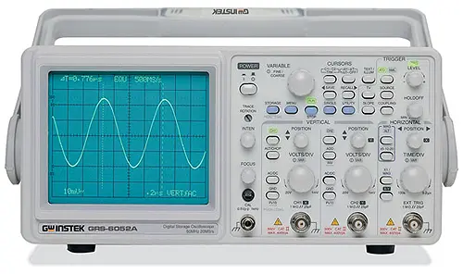

An oscilloscope, often referred to as an "oscilloscope" or simply a "scope," is a vital test instrument used in the field of electronics and electrical engineering. Its primary function is to visualize and analyze electrical signals, allowing engineers and technicians to observe how these signals change over time.

1. **Importance in Computer Engineering**

Oscilloscopes hold immense significance in computer engineering:

* 1. **Diagnosing and Troubleshooting:** They are indispensable for identifying and resolving electronic circuit issues, ensuring the reliability of computer hardware.
  2. **Signal Characterization:** Oscilloscopes precisely measure signal parameters like frequency, amplitude, and jitter, critical for optimizing signal integrity in data transmission.
  3. **Performance Verification:** Engineers use oscilloscopes to validate the performance of digital systems, ensuring they meet specified standards and requirements.
  4. **Real-Time Analysis:** The ability to provide real-time insights into electrical waveforms enables immediate detection of anomalies, enhancing computer system reliability.
  5. **Design Validation:** Oscilloscopes aid in verifying the integrity of hardware designs, ensuring computers function as intended, making them indispensable tools in computer engineering.

1. **Oscilloscope Operations**

Oscilloscopes are versatile instruments used for various operations in electronics and computer engineering:

* 1. **Signal Visualization**: Oscilloscopes display electrical waveforms, allowing engineers to visually examine signal shapes, amplitudes, and frequencies.
  2. **Time-Domain Analysis:** They measure how signals change over time, crucial for assessing signal stability, noise, and timing accuracy.
  3. **Frequency Analysis:** Oscilloscopes can perform Fourier analysis to decompose complex signals into their frequency components, aiding in identifying unwanted noise or harmonics.
  4. **Jitter Analysis:** Engineers use oscilloscopes to quantify signal jitter, essential for high-speed digital communication systems where timing precision is critical.
  5. **Voltage and Current Measurements:** These instruments accurately measure voltage and current levels in electronic circuits, helping engineers ensure proper operation and adherence to specifications.
  6. **Triggering:** Trigger functions allow oscilloscopes to capture specific events or anomalies in signals, facilitating in-depth analysis.
  7. **Probe Compensation:** Users can calibrate oscilloscope probes to maintain measurement accuracy and signal fidelity.
  8. **Data Storage and Analysis**: Many modern oscilloscopes offer data storage capabilities, enabling engineers to capture, analyze, and compare waveforms over time.
  9. **Protocol Analysis:** Advanced oscilloscopes support decoding and analysis of digital communication protocols like I2C, SPI, or UART, aiding in debugging digital systems.

Understanding and mastering these oscilloscope operations are essential skills for professionals in the field of computer engineering.

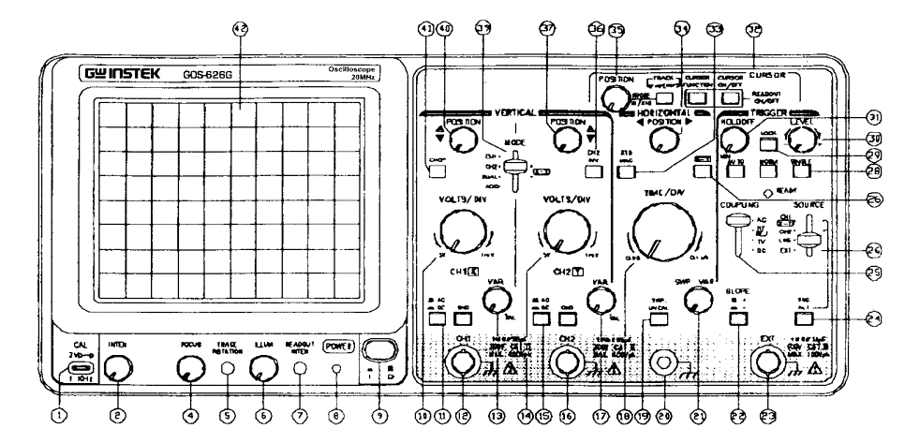

**Lab Task 01**

**Try** to explore the Front Panel of GW Instek 20 MHz Oscilloscope.

**[CLO-01, PLO-01, P3(Guided Response), Rubric (Hardware Configurations)]**

**Rubric:**

|  |  |  |  |  |
| --- | --- | --- | --- | --- |
| **Marks** | **1** | **2** | **3** | **4** |
| **Hardware Configurations** | The hardware configuration is not as per guidelines and requirements are not met | Some section of hardware configuration is correct | Most section of hardware configuration is correct and understands it well | The hardware configuration is properly done, and have good understanding about it |

**Objective:** In this lab task, you will examine the front panel of the GW Instek 20 MHz Oscilloscope and explore its various knobs, buttons, and features to understand their functions. You will also determine the number of channels and decipher the significance of the "20 MHz" specification.

**Equipment Needed:**

* GW Instek 20 MHz Oscilloscope
* Datasheet for the Oscilloscope (provided separately)

**Procedure:**

1. **Overview of the Front Panel:**
   * Locate the front panel of the GW Instek 20 MHz Oscilloscope.
   * Take a moment to visually inspect the panel and identify its key components, including knobs, buttons, and displays.
2. **Identifying Knobs and Buttons:**
   * Refer to the provided datasheet for the oscilloscope.
   * Match the components on the front panel with the descriptions in the datasheet to determine the function of each knob and button.
   * Make a list of the identified components and their functions.
3. **Determining the Number of Channels:**
   * Look for any indicators or labels that specify the number of input channels on the oscilloscope.
   * Refer to the datasheet to confirm the number of channels.
   * Note down how many input channels the oscilloscope has.
4. **Understanding "20 MHz" Specification:**
   * Locate the "20 MHz" specification on the front panel.
   * Refer to the datasheet to understand what this specification represents.
   * Write a brief explanation of what the "20 MHz" specification means in the context of the oscilloscope.
5. **Optional Exploration:**
   * If time permits, you can explore additional features or buttons on the front panel not covered in the datasheet.
   * Try to determine their functions or purposes.

**Conclusion:** After completing this lab task, you should have a clear understanding of the front panel components and their functions on the GW Instek 20 MHz Oscilloscope. You will also know the number of input channels and the significance of the "20 MHz" specification. This knowledge will be essential for using the oscilloscope effectively in various electronic experiments and measurements.

**Lab Task 02**

**Practice** thecalibration of GW Instek Oscilloscope 20 MHz.

**[CLO-01, PLO-01, P3(Guided Response), Rubric (Hardware Configurations)]**

**Rubric:**

|  |  |  |  |  |
| --- | --- | --- | --- | --- |
| **Marks** | **1** | **2** | **3** | **4** |
| **Hardware Configurations** | The hardware configuration is not as per guidelines and requirements are not met | Some section of hardware configuration is correct | Most section of hardware configuration is correct and understands it well | The hardware configuration is properly done, and have good understanding about it |

Top of Form

**Objective**: To calibrate the oscilloscope for accurate voltage measurements.

**Concept of Calibration**: Calibration is the process of adjusting and setting up a measurement instrument to ensure its accuracy and reliability. Over time, instruments may drift from their original accuracy due to factors such as wear and tear or changes in environmental conditions. Calibration helps bring the instrument back to its specified accuracy.

**Why Calibration is Important**:

* Ensures the accuracy of measurements.
* Provides consistent and reliable results.
* Guarantees that the instrument is operating within its specified tolerances.
* Minimizes measurement errors, which is crucial in various fields like electronics, engineering, and science.

**Steps to Calibrate the Oscilloscope:**

1. Connect main power switch.
2. Turn oscilloscope On.
3. Select source CH1 or CH2.
4. Set VOLTS/DIV mode to CH1 or CH2.
5. Set the VOLTS/DIV control to 1.
6. Set the TIME/DIV control to 1 ms.
7. Set the trigger switch to auto.
8. Connect the probe to the input connector.
9. Align horizontal beam line along X-axis by moving position knob (horizontal/vertical).
10. Touch the end of probe to the scope’s calibration terminal.
11. If necessary, adjust TIME/DIV and VOLTS/DIV controls until the square wave fits nicely within the display.
12. 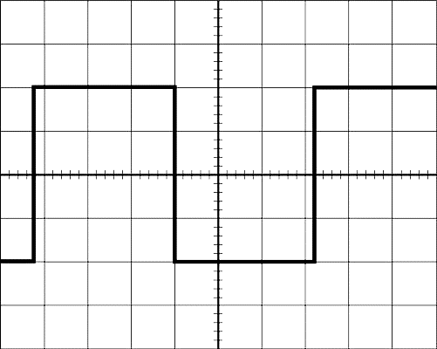Check peak to peak value according to calibration requirement mention on oscilloscope terminal (2V p-p).

**Lab Task 03**

**Try** tolearn how to measure and calculate key signal parameters using a GW Instek analog oscilloscope.

**[CLO-01, PLO-01, P3(Guided Response), Rubric (Hardware Configurations)]**

**Rubric:**

|  |  |  |  |  |
| --- | --- | --- | --- | --- |
| **Marks** | **1** | **2** | **3** | **4** |
| **Hardware Configurations** | The hardware configuration is not as per guidelines and requirements are not met | Some section of hardware configuration is correct | Most section of hardware configuration is correct and understands it well | The hardware configuration is properly done, and have good understanding about it |

**Materials:**

* GW Instek Analog Oscilloscope (20 MHz model)
* BNC Cable (BNC stands for "Bayonet Neill–Concelman," and it refers to a type of electrical connector that is commonly used in electronic and RF (radio frequency) applications.)
* Pen and Paper

**Procedure:**

**Part 1: Setting Up the Oscilloscope**

1. Turn on the GW Instek oscilloscope and let it warm up for a few minutes.
2. Connect the BNC cable to the signal output of the function generator.
3. Connect the other end of the BNC cable to Channel 1 (CH1) input of the oscilloscope.
4. Ensure that the function generator is set to produce a known waveform, such as a sine wave or a square wave.

**Part 2: Measuring Signal Parameters**

**Amplitude Measurement:** 5. Adjust the "Volt/Div" knob on CH1 to a suitable setting, such as 1V/div or 2V/div, to clearly view the waveform on the oscilloscope screen.

1. Measure the amplitude (A) of the signal by determining the voltage difference between the highest and lowest points of the waveform. Record this value.

**Peak-to-Peak Voltage Measurement:** 7. Measure the peak-to-peak voltage (Vpp) by calculating the voltage difference between the maximum positive and maximum negative points on the waveform. Record this value.

**Time Period Measurement:** 8. Adjust the "Time/Div" knob on the horizontal axis to set an appropriate time scale for your waveform display, e.g., 1 ms/div or 10 ms/div.

1. Measure the time period (T) of one complete cycle of the waveform. This is the time it takes for the waveform to repeat itself. Record this value.

**Frequency Calculation:** 10. Calculate the frequency (f) of the signal using the formula: f = 1 / T, where T is the time period measured in step 9. Record the frequency.

**Task Questions:**

1. What is the amplitude (A) of the signal in volts?
2. What is the peak-to-peak voltage (Vpp) of the signal in volts?
3. What is the time period (T) of the signal in seconds?
4. What is the frequency (f) of the signal in hertz (Hz)?

**Conclusion:** Summarize your findings and discuss the importance of measuring these parameters when working with electronic circuits and signals. Explain how accurate measurement of amplitude, peak-to-peak voltage, time period, and frequency is essential for diagnosing and troubleshooting electronic systems.

**Lab Report Rubric:** *must be submitted in next lab***.**

|  |  |  |  |  |
| --- | --- | --- | --- | --- |
| **Marks** | **1** | **2** | **3** | **4** |
| **Lab Report** | The lab report does not follow the guidelines for formatting. | Presents some sections of the lab in the correct order. Three or more sections are not in the correct order; missing heading or title; | Presents most sections of the lab in the correct order, one or two sections may not be in the correct order; heading or title missing or not complete; | Presents all the sections of the lab in the correct order with correct formatting: includes correct heading, section headings and title of lab; |

Top of Form